From: https://davidstockmanscontracorner.com/the-tweeter-in-chief-needs-a-day-job/

The Tweeter-In-Chief Needs A Day Job
By David Stockman. Posted On Tuesday, May 14th, 2019
Would someone please give Donald Trump a day job!
He's already tweeted 13 times today, and each one seems to be more out to lunch than the last. For instance, bright and early at 6:15 AM he was he was praising himself for a "booming" steel industry:
In one year Tariffs have rebuilt our Steel Industry - it is booming! We placed a 25% Tariff on “dumped” steel from China & other countries, and we now have a big and growing industry. We had to save Steel for our defense and auto industries, both of which are coming back strong!
6:15 AM - 14 May 2019
You can see the problem in the chart below. What the Donald defines as "booming" is apparently any and all handiworks for which he wishes to take credit, not the mundane facts of the matter.
As it happens, domestic steel production in March 2019 was actually 7.5% below where it was after the post-recession rebound in February 2012, and fully 18% below the pre-crisis peak in mid-2008.
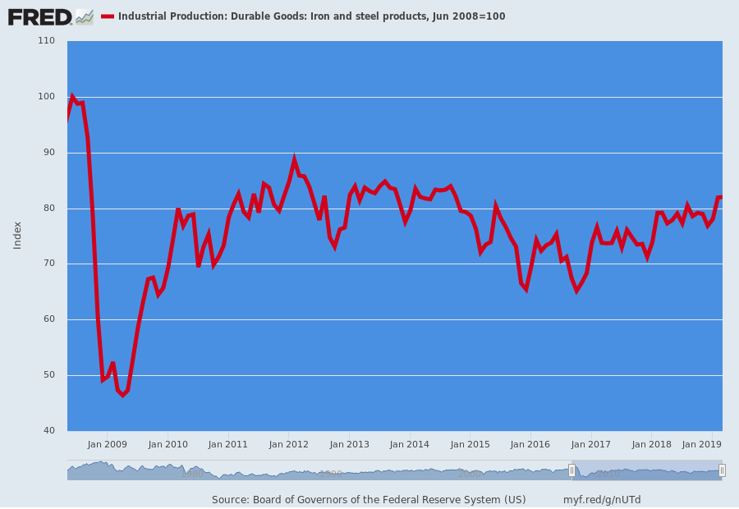
And, of course, that's to say nothing of the adverse impact of Trump's 25% steel tariff on downstream user industries. Costs to domestic steel users have risen by about $11.5 billion owing to the tariff increases, but even by the lights of the Alliance for American Manufacturing, the lobby group which has advocated for Trump's action, only about 12,700 new steel industry jobs have been added.
The math tell you all you need to know. That's about $900,000 per job and its not a formula for MAGA by any stretch of the imagination.
At the end of the day, the problem of protectionism--even setting aside the philosophical principle that consumers and businesses should have the right to buy goods from wherever they choose without facing arbitrary tax penalties---is simply a variation of the problem of socialist calculation that Hayek addressed a century ago.
That is, arbitrary tariffs by product line or country of origin ricochet through the infinite complexity of a $20 trillion economy in ways that Washington Trade Nannies can't begin to fathom.
For instance, there are 11,800 iron and steel jobs in Pennsylvania, 7,700 in Ohio and 18,100 in Indiana, representing the three principle steel producing states. By contrast, there are 1.485 million jobs in the steel fabrication sector.
As is evident in the chart below, the steel using sectors have been struggling to simply regain the production and employment levels that existed prior to the Great Recession. In fact, after recovering to 1.472 million jobs by January 2015, the industry went through a global production and inventory dip and has come out about where it started--posting barely 15,000 additional jobs in more than four years.
Now, one reason for this tepid growth is that these fabricated metal products companies also face fierce competition from imports, and their competitors more often than not have access to the same cheap international steel--much of it from China---that the Donald is always grousing about and on which he slapped his 25% tax.
So the truth is, the steel tariffs have been a net destroyer of jobs, as downstream steel using industries have, ironically, lost market share to importers.
For instance, American Keg represents a typical example of the invisible impact on small businesses in particular as higher steel costs are passed on to customers:
The Pennsylvania stainless-steel beer keg manufacturer was forced to lay off 10 of its 30 employees because of tariff-induced costs. It has passed on some of the costs through higher prices, leading some customers to switch to foreign vendors. “We have a lot of patriotic customers that want to buy USA-made kegs with U.S. labor and U.S. steel,” the company’s CEO says, “but they’re only going to go so far as that price difference continues to rise.”
That really shouldn't be so hard to understand, nor the counterproductive adjustments that domestic steel users have been forced to undertake. For example, Batesville Tool & Die did the very opposite of what Trump promised: It shifted some production to one of its plant in Mexico so that it could get access to untaxed steel.
Actually, we can speak with some experience and authority on this matter because back in our private equity days we were heavily invested in the metal-working and fabricating industries like bolts and fasteners, trailer frames and hitches, RV and auto components and precision machining.
In virtually every case we had production in both US and Mexican plants, and we also faced fierce competition from foreign suppliers of these same fabricated metal products. And in response to the Donald's 25% tariff we are quite sure what would have happened next.
To wit, we would have lost some volume and market share to foreign suppliers of fasteners and engineered parts and would have moved as much production as possible to Mexican plants which could source international steel without paying the Donald's tariff.
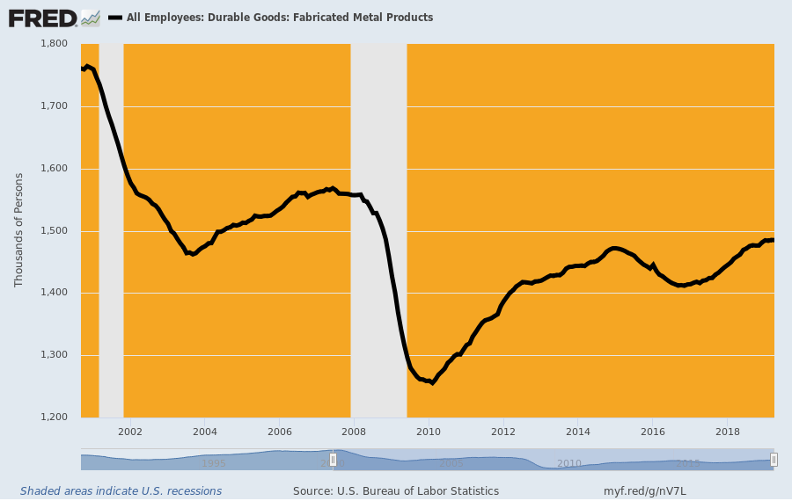
The fact is, when you drop a tariff in the middle of a complex supply chain, nothing stands still. The compensating adjustments tumble through the economy like a table full of careening billiard balls. At length the losses exceed the gains because companies had sourced from abroad for a reason: that is, to lower costs and improve their competitive position in their own end markets, not for want of patriotic virtue.
In short, the Donald is a bull in the China shop on trade because he has no working knowledge of how production, sourcing and supply chains actually function in the real world; and also because his views on trade are really not even grounded in thinking or even some kind of marginally thought-out protectionist philosophy.
To the contrary, Trump's protectionism is entirely glandular and rooted in his over-weaning egotism. He thinks trade is like basketball: A zero-sum game where the bilateral scoreboard reveals winners (surplus countries) and losers (deficit countries).
His AM tweet storm said exactly that and the quote below came barely 36 minutes after his steel boasting. And it had nothing to do with the economics of the China trade deal which has just gone into deep limbo.
After all, in all the strategic White House leaking about the alleged "progress" that was being made prior to Sunday, there has never been one claim about the "huuge" number of jobs that would come back to America as a result of the pending deal.
That's because most of the "deal" is driven by Lighthizer and the K-Street lobbies. And it's focussed on the profits and convenience of Fortune 500 company investments in the Red Ponzi and the amelioration of its onerous practices on technology-sharing, joint venture ownership, licensing and royalty rates for patents and intellectual property and investments in quasi-closed sectors like insurance and finance.
As we have frequently insisted, progress on these items might put a smile on the face of CEOs who go on CNBC to brag about their China-based growth strategies, but what in the world do these issues have to do with bringing production, jobs and incomes back to America?
Indeed, it now seems certain that the Donald intends to go the full monte with a 25% tariff on all $563 billion of imports from China, which amounts to a $140 billion unguided missile aimed at American consumers, retailers and importers of intermediate goods and production parts. That is to say, the Donald has turned the negotiations over to a K-Street lawyer who has no compunction whatsoever about employing the powers of the state in behalf of the powerful few at the expense of the innocent many.
That's what swamp creatures do, and Lighthizer has spent 45 years perfecting the art.
To be sure, Lighthizer & Co are working a big scam calling for a large step-up in Chinese purchases of US exports. But that's mainly a sop to the Donald's mercantilism, not anything which will change the fundamental economic imbalance that resulted in $120 billion of US exports to China last year or just 21% of the $563 billion of goods the US imported from the Red Ponzi.
The latter is a function of bad money and the Fed's misbegotten pursuit of 2.00% inflation and Wall Street oriented wealth effects policies which have caused the C-suites of corporate America to become stock trading rooms and financial engineering joints.
Yet even aside from ignoring the fundamental monetary drivers that have caused the off-shoring of much of America's former industrial economy, lawyer Lighthizer is essentially pushing a ruse in the form of the stepped-up purchase of US exports, whether he recognizes the circular economics or not.
That's because most of it is focused on farm, energy and materials commodities which are totally fungible in world trade. For instance, if a truce is achieved and China agrees to buy more soybeans, crude oil and LNG, will that increase production and jobs stateside?
Actually, it will mainly cause a big swap-out in the global sourcing networks. China will buy more soybeans from the US and less from Brazil, and, in turn, Brazil will pick-up non-China customers from the US.
As is evident in the chart below, USA planted soybean acreage has increased nearly 50%---from 60 million to 90 million acres---since the early 1990s in response to growth in the world market, including China and its hungry horde of 440 million hogs (compared to 73 million hogs in the US and just 9 million in Japan).
So it's not as if the midwest is brimming with unused acreage and idle farmers. Except for relative corn/soybean price differentials which can shift a few million acres on the margin from year to year, America's farms are already planted from hedgerow to hedgerow.
Stepped up China purchases won't cause any appreciable increase in planted acreage, production or farm incomes; it will just change the shipping manifests from their current destinations to Chinese ports.
Moreover, the same is true of crude oil exports and even LNG. When China buys more, some other nation will buy less. That's because we are dealing with global commodity markets where everything that can be produced gets sold at prices which clear the markets.
All of Lighthizer fancy lawyering and multi-hundred pages agreements of dense legalize, will not generate more global demand for these products or even appreciably better prices and profits.
In a word, the sought after step-up purchases of US export is simply a beltway racket, not a route to MAGA.
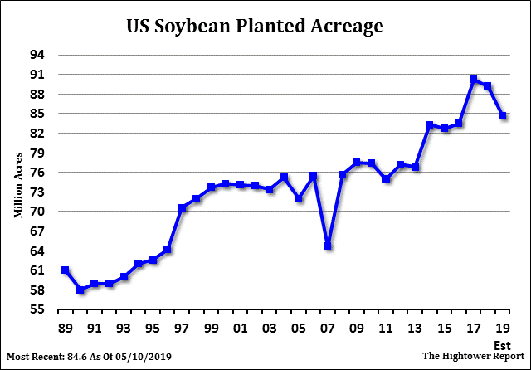
In any event, the Donald does not trouble himself with the substance of these matters. His aim is to "win" and that's exactly why disaster is lurking around the bend.
We can make a deal with China tomorrow, before their companies start leaving so as not to lose USA business, but the last time we were close they wanted to renegotiate the deal. No way! We are in a much better position now than any deal we could have made. Will be taking in....Billions of Dollars, and moving jobs back to the USA where they belong. Other countries are already negotiating with us because they don’t want this to happen to them. They must be a part of USA action. This should have been done by our leaders many years ago. Enjoy!
6:51 AM - 14 May 2019
We unloaded some of these thoughts earlier today on Cheddar TV Business.
https://www.youtube.com/watch?v=0887L5pkvZU&feature=youtu.be

